CSA-0908 JAVA PROGRAMMING

**DAY-1**

1. USERNAME VALIDATE

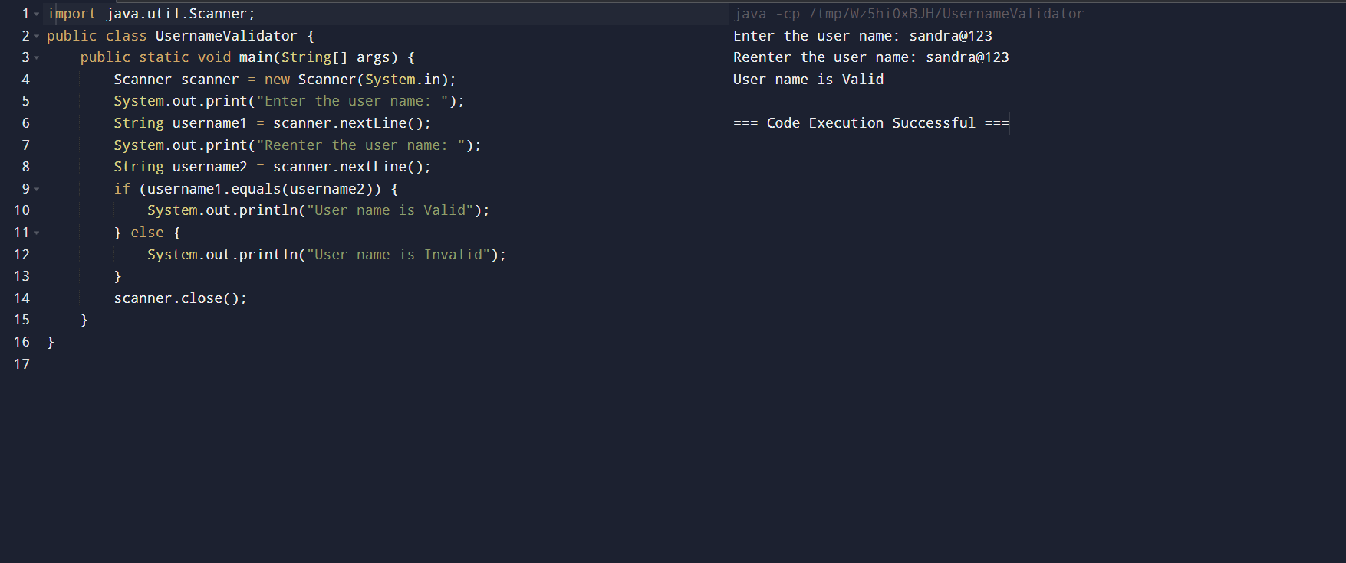

1. REVERSE NUMBER USING LOOP

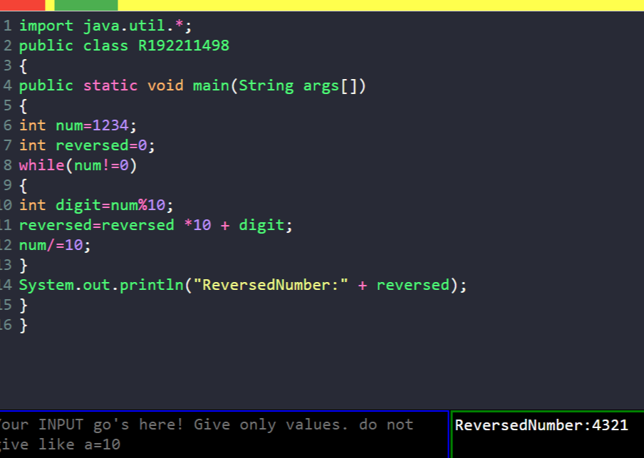

1. REVERSE WORD USING LOOP

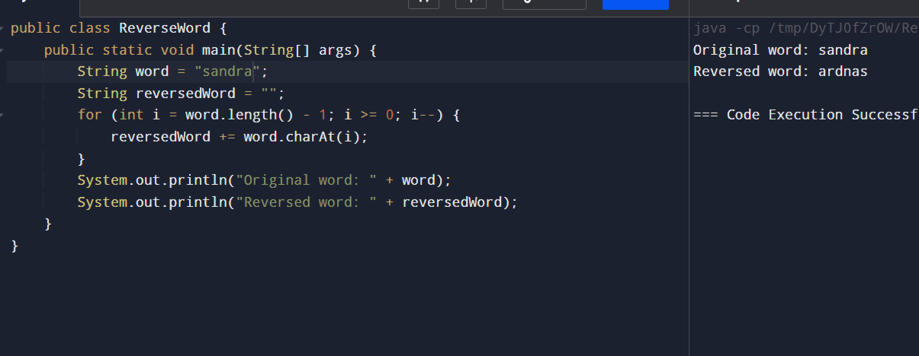

4)ELIGIBLE FOR VOTE

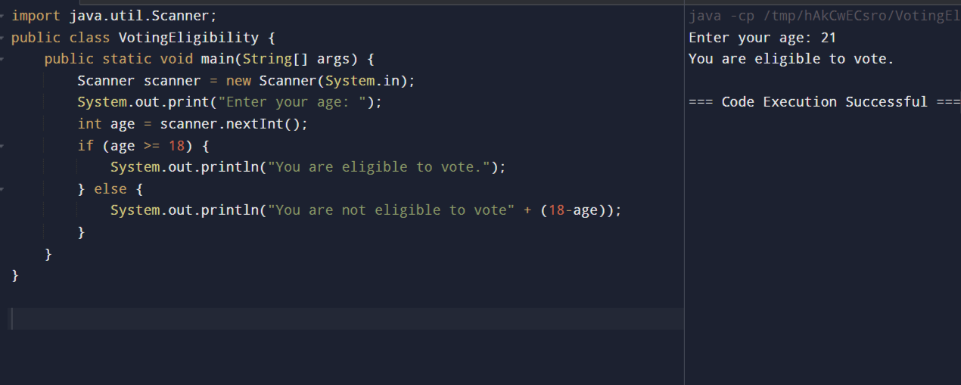

5)LCM AND GCD

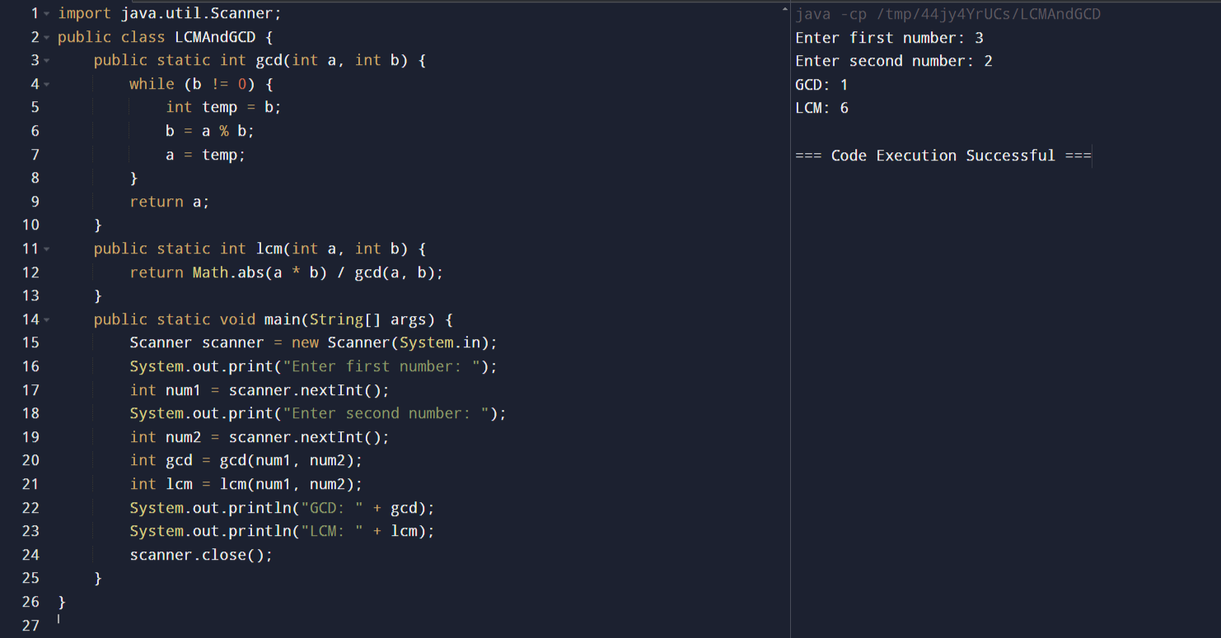

6)RIGHT TRIANGLE STAR PATTERN

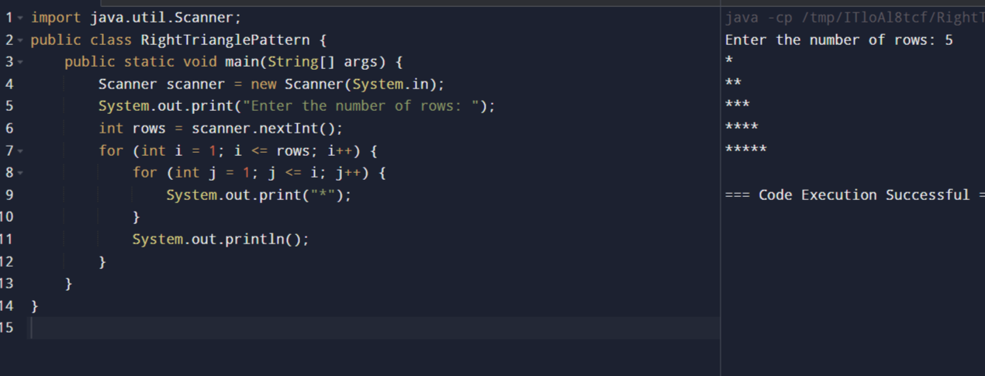

7)SIMPLE INTEREST

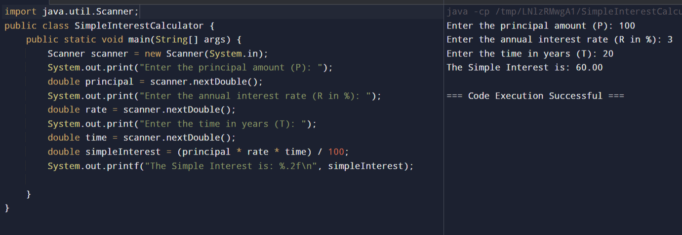

8) EVEN SUM OF FIBONACCI SERIES TILL N

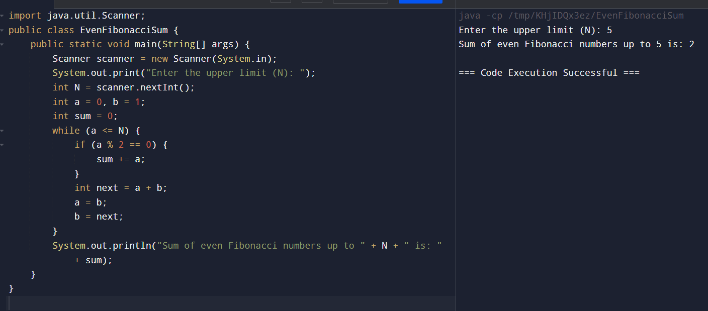

9) PRINT NUMBERS FROM M TO N BY SKIPPING K NUMBERS

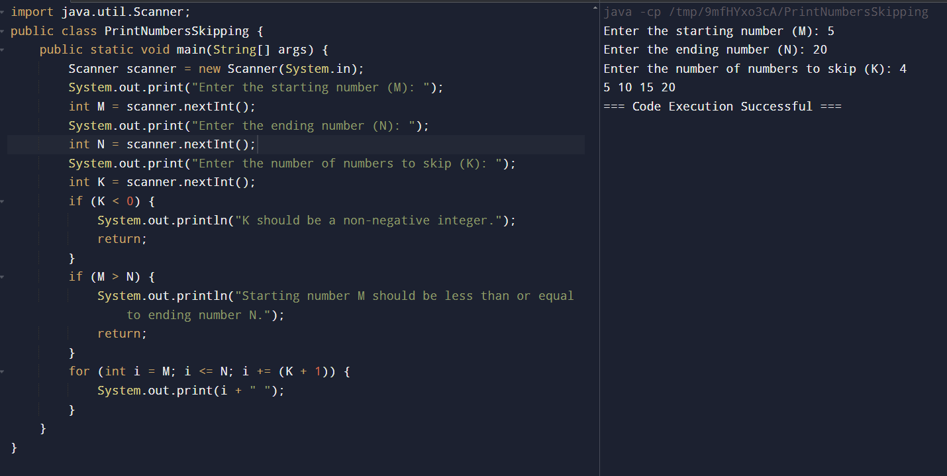

10) MATRIX ADDITION

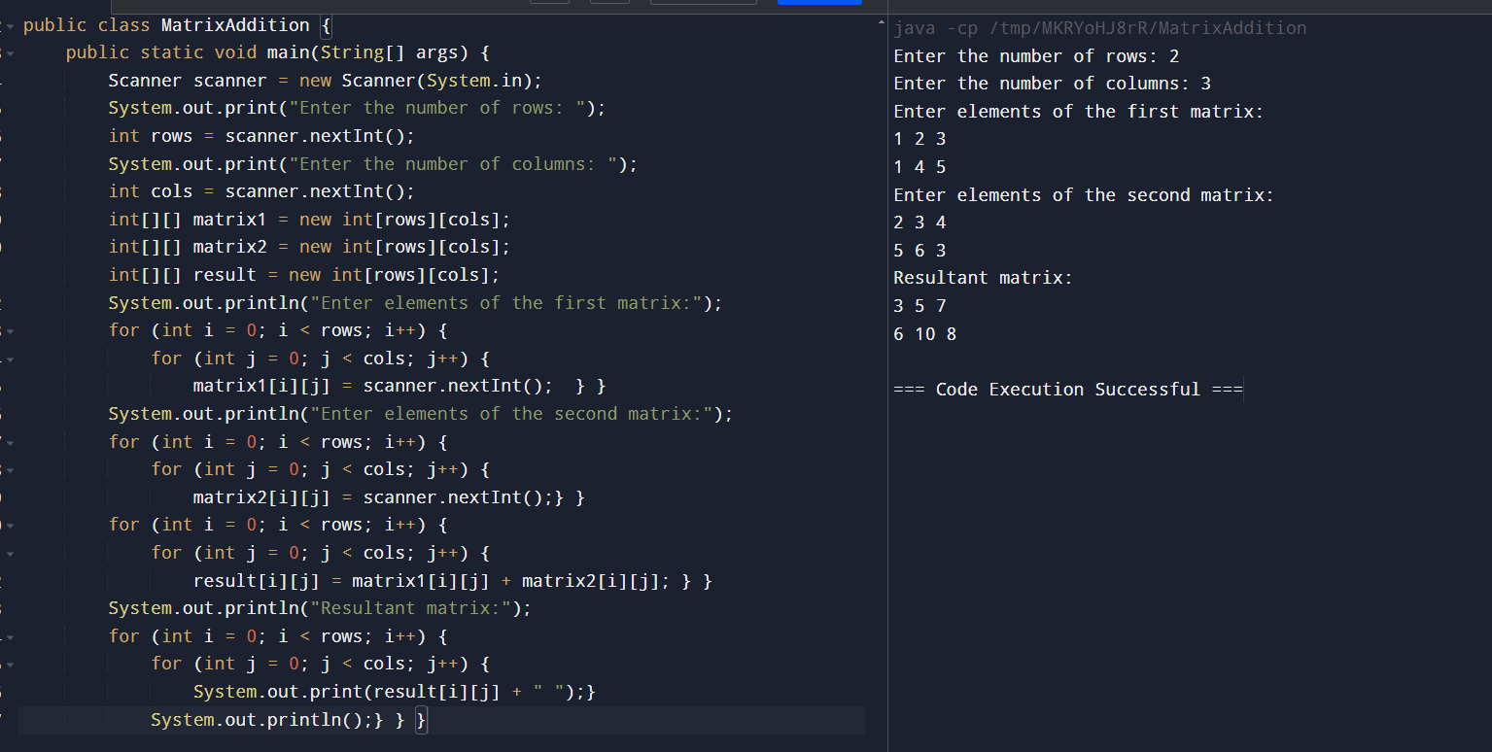

11) RECTANGLE SYMBOL PATTERN

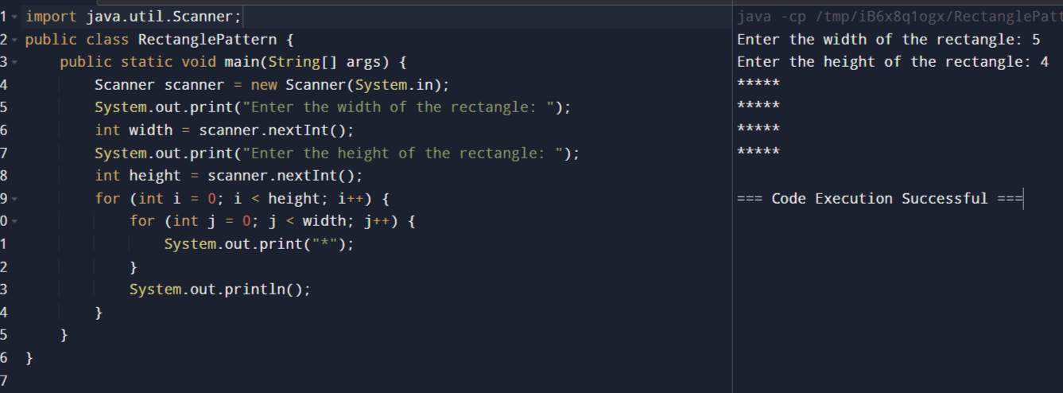

12) PATTERN PRINTER

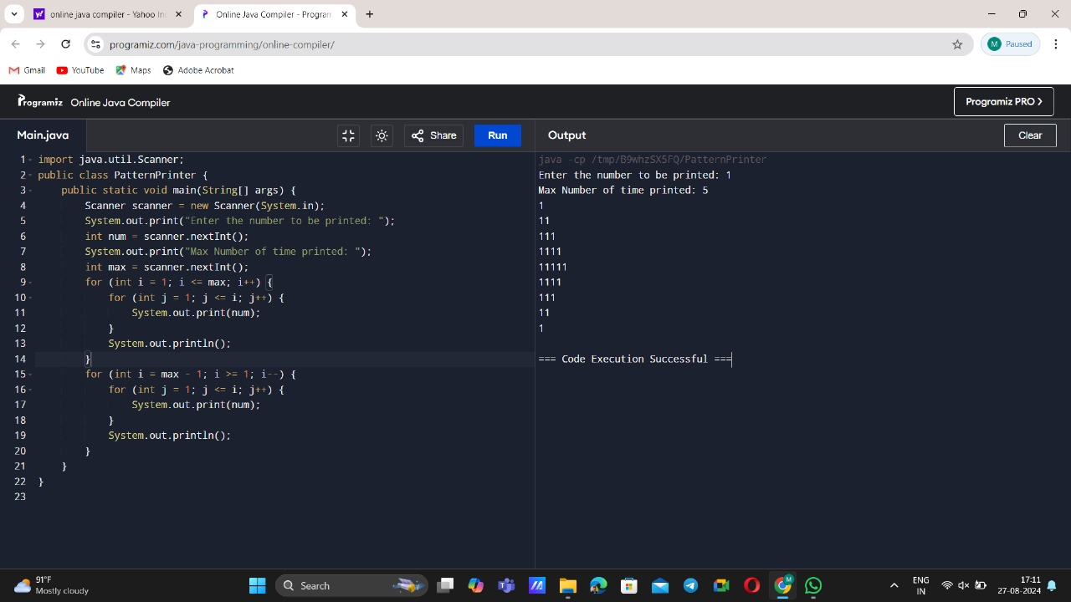

13) COMPOSITE NUMBERS

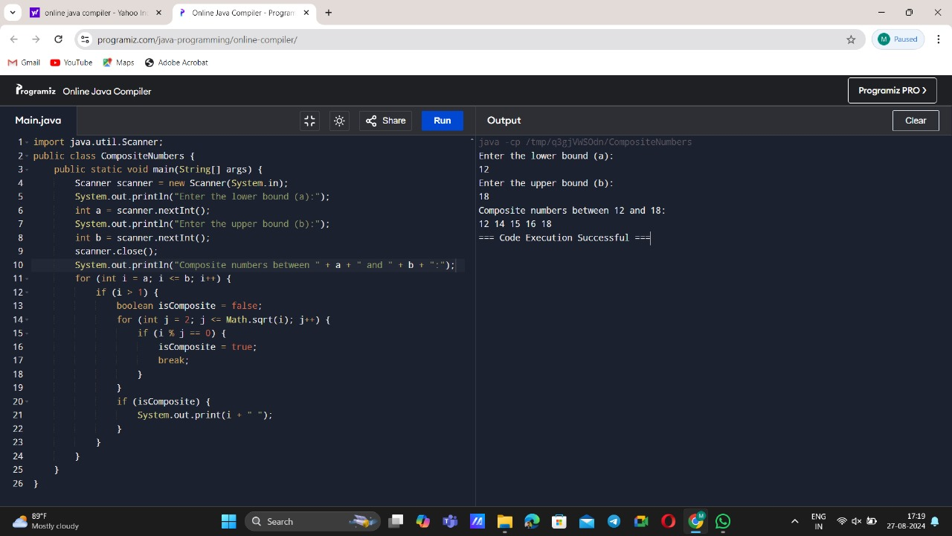

14) INVERTED FULLY PYRAMID

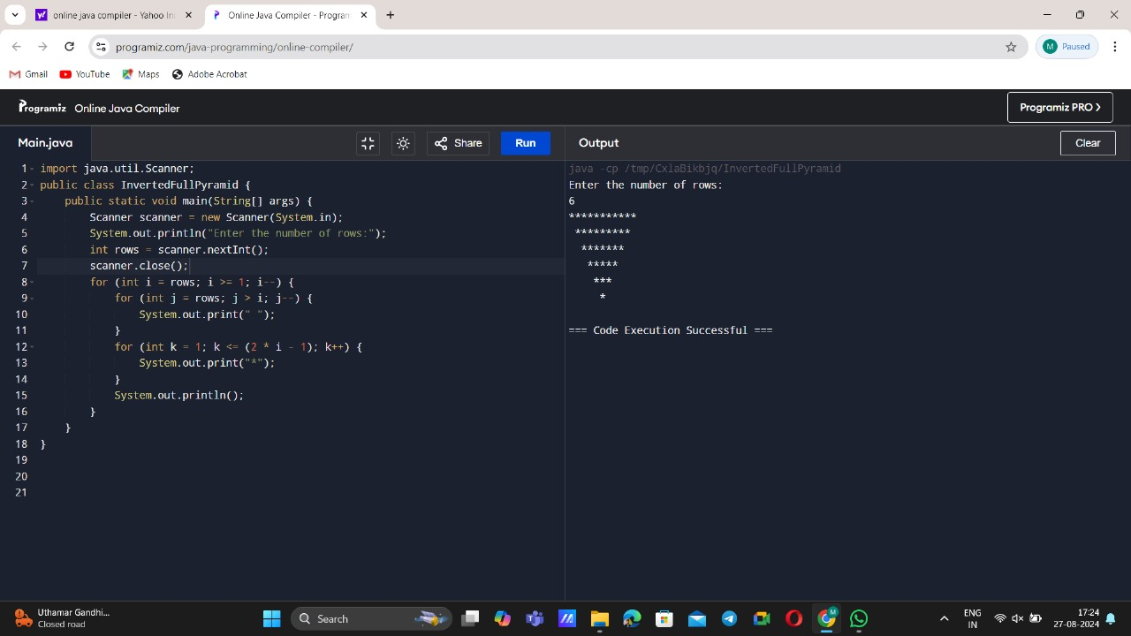

15) SPECIAL CHARACTERS

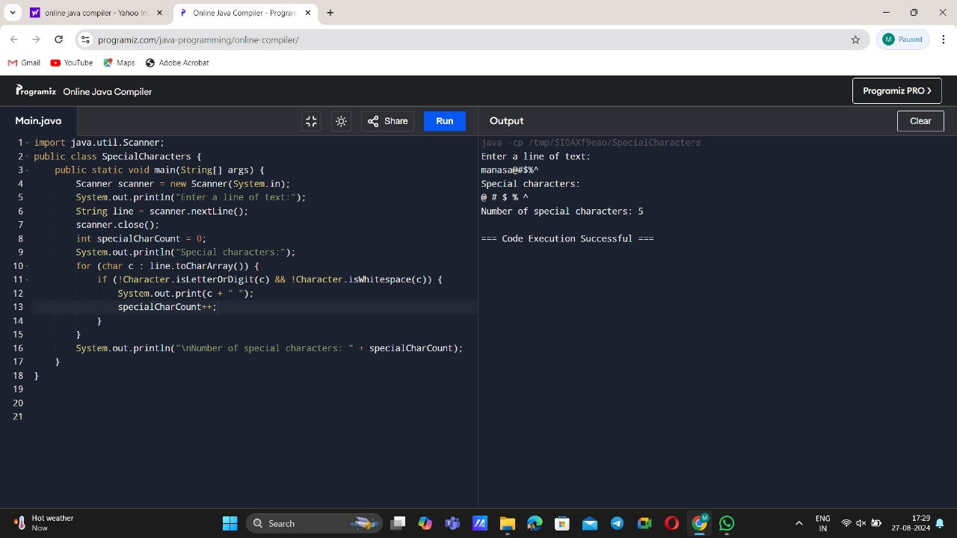

**DAY – 2**

16) ALPHABETICAL ORDER

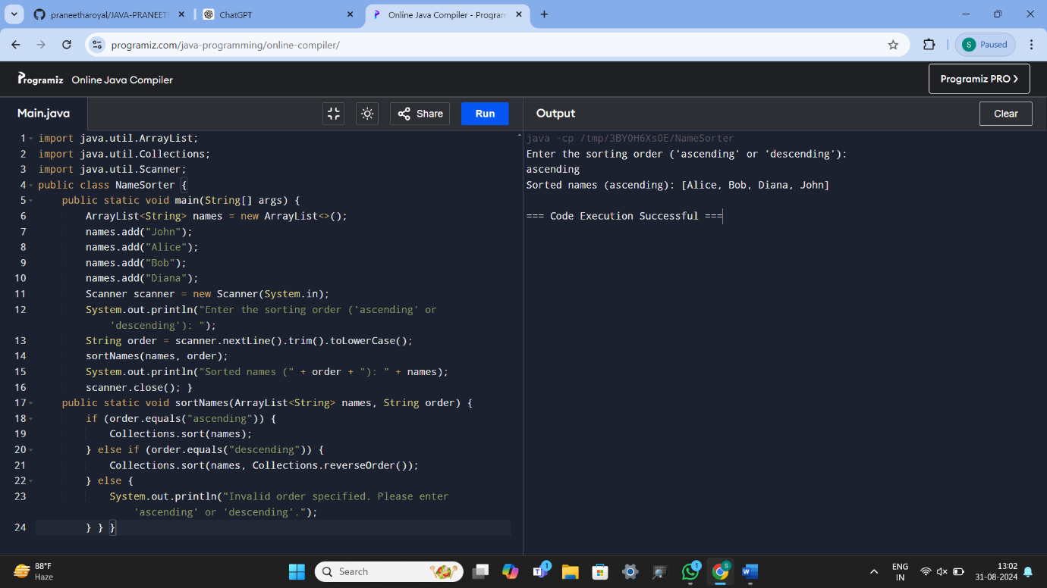

17) MEAN, MODE, MEDIAN

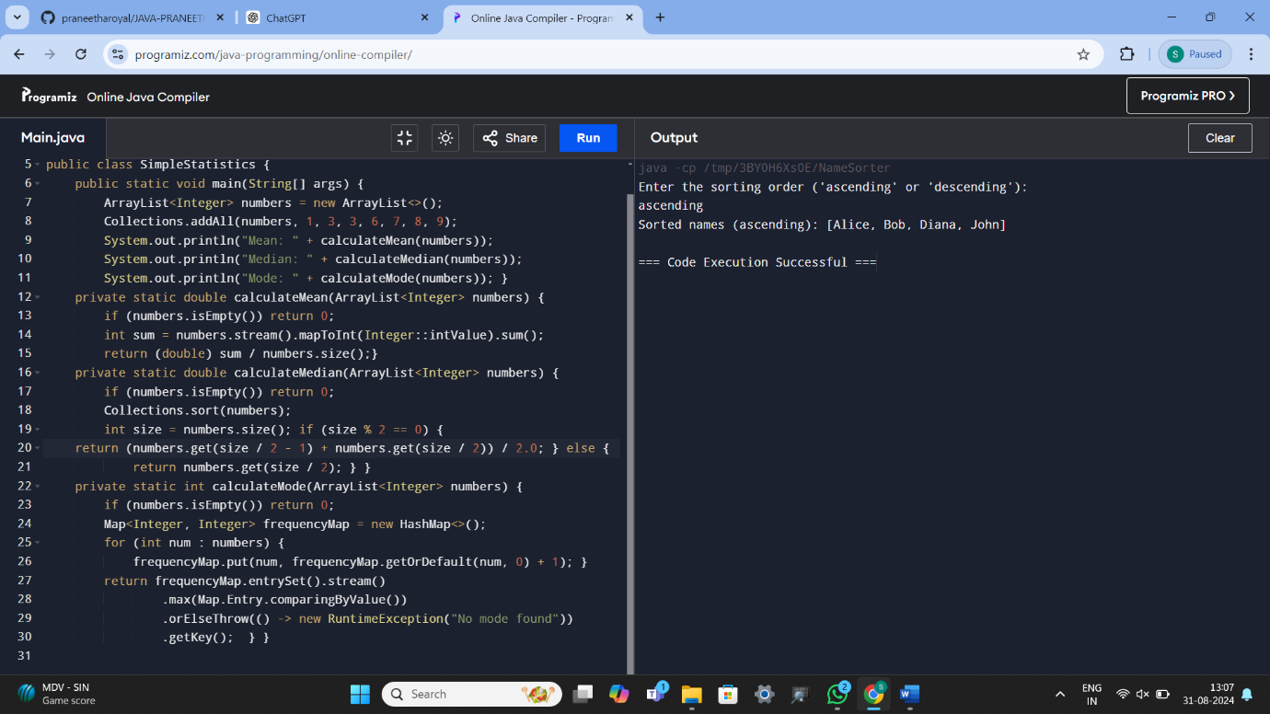

18) MATRIX MULTIPLICATION

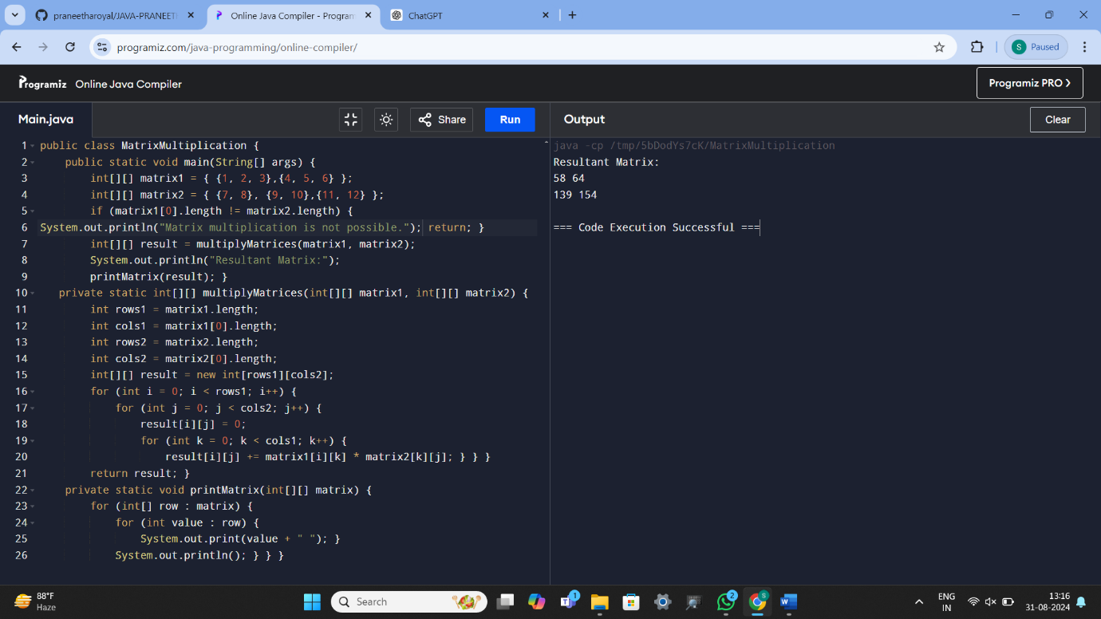

19) LEAP YEAR

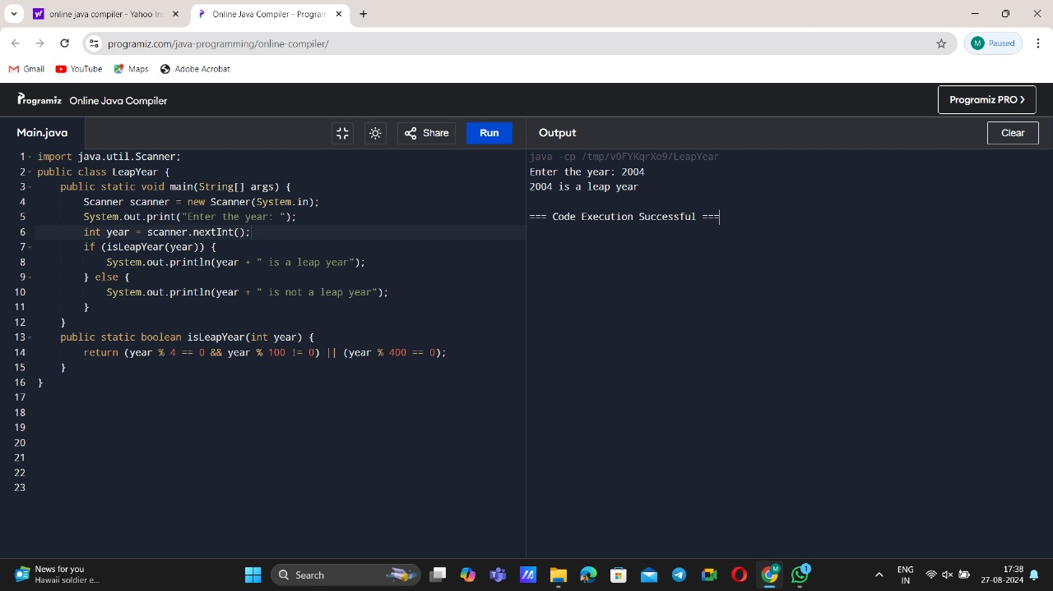

20) PATTERN PRINTER

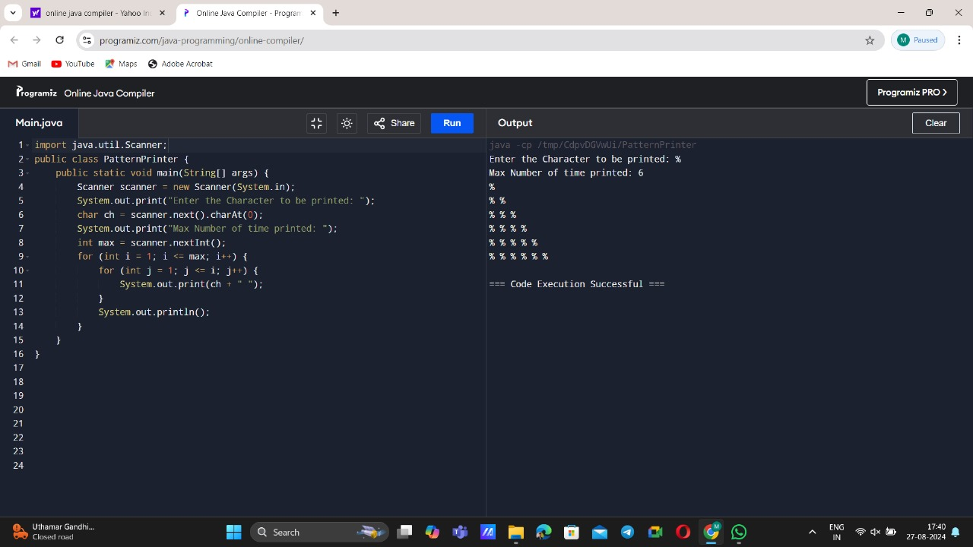

21) PERFECT NUMBER

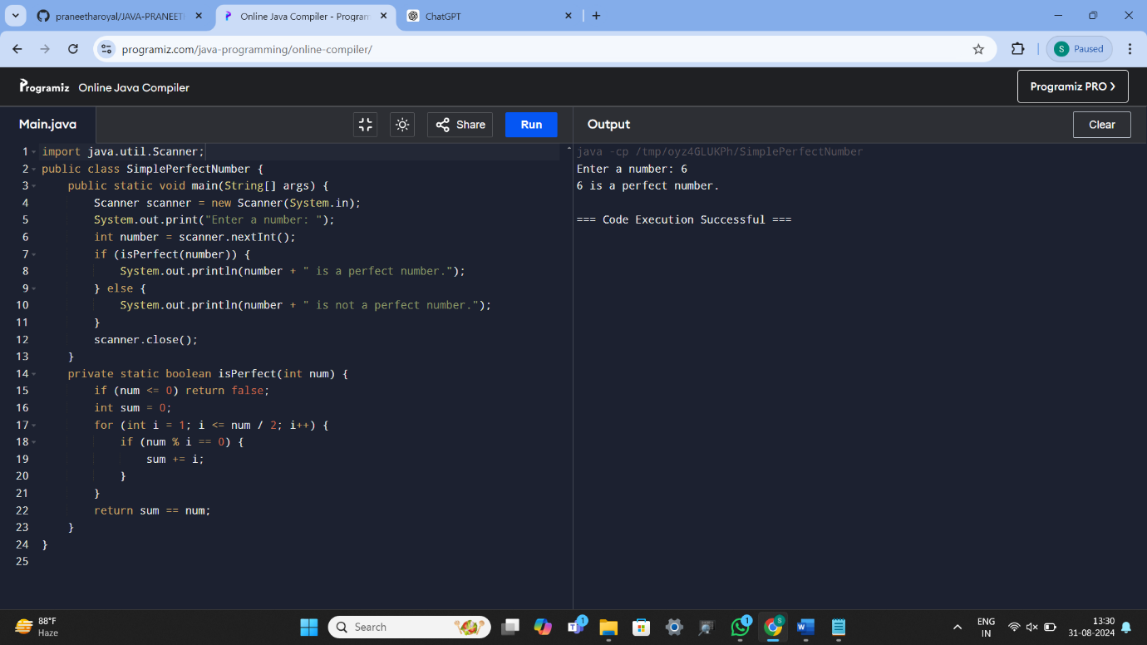

22) FACTORIAL OF GIVEN NUMBER

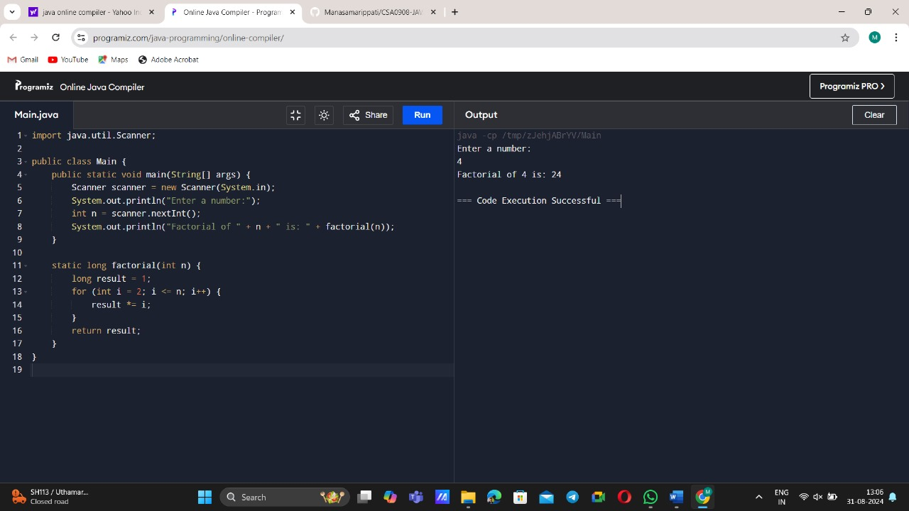

23) FACTORS OF GIVEN NUMBER

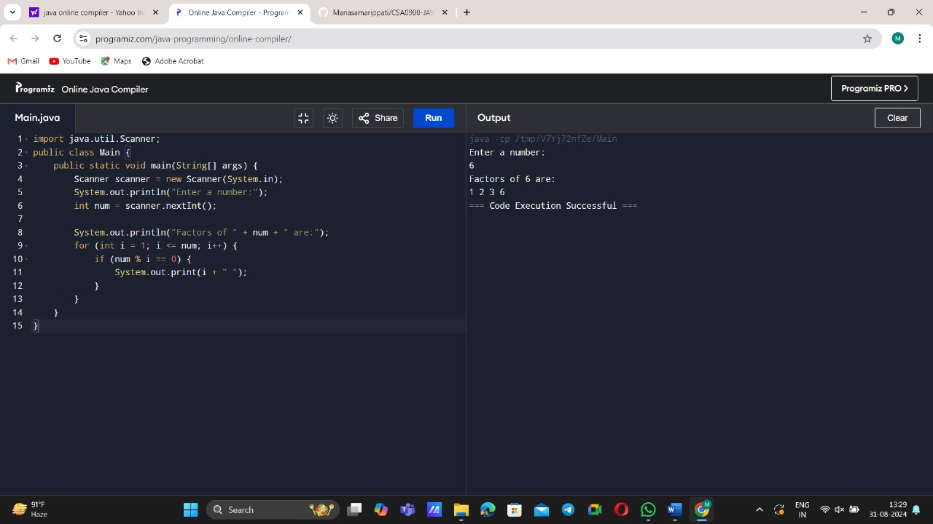

24) VOWEL COUNT

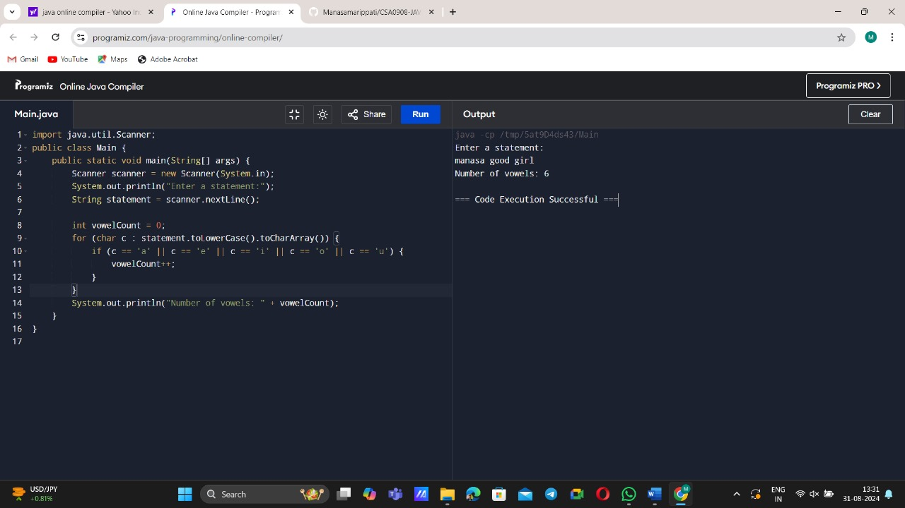

25) FIBONACCI SERIES

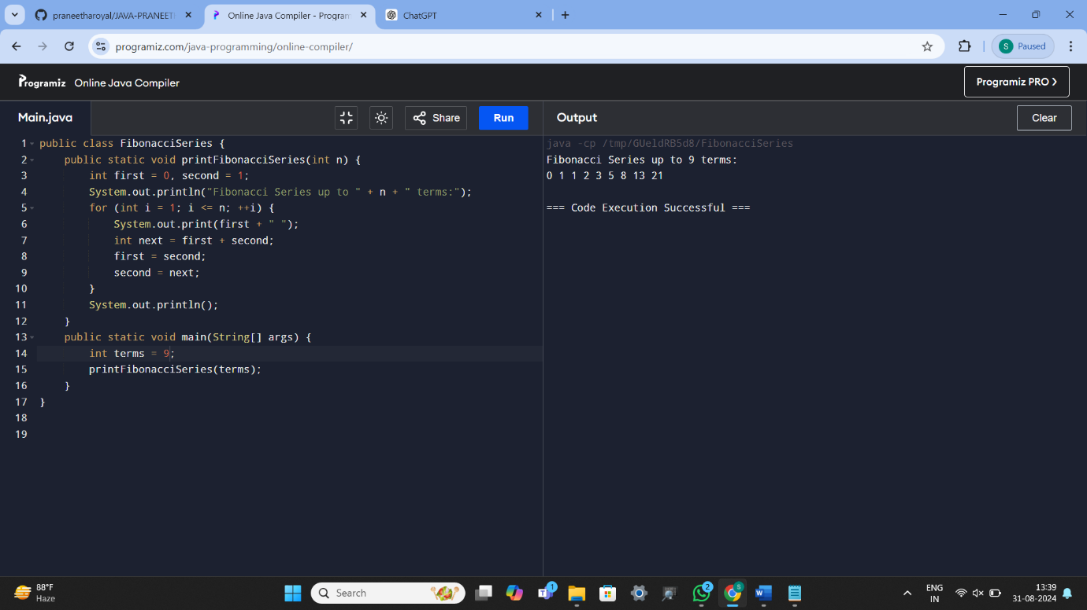

26) CONSONANTS AND VOWELS

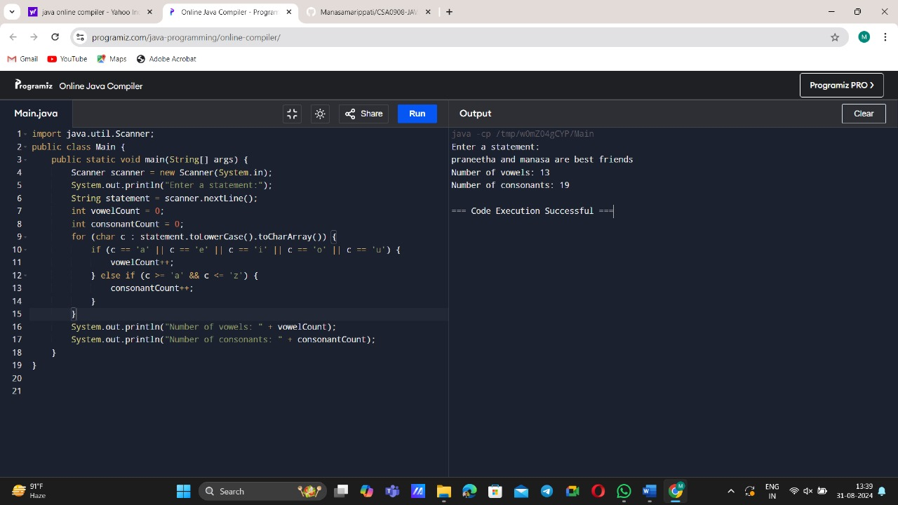

27) PASCAL PATTEREN PRINTER

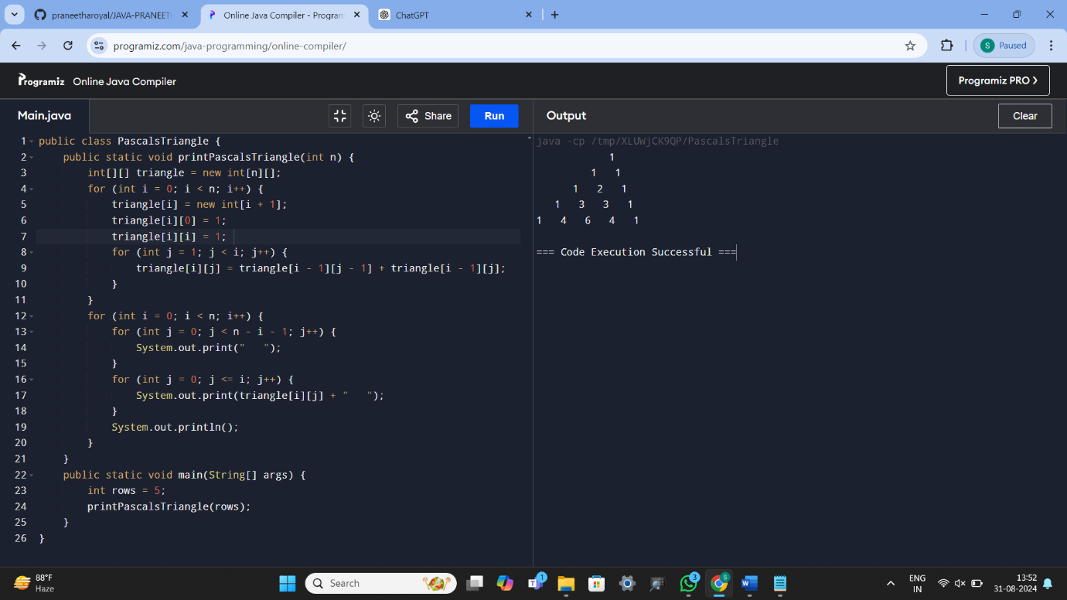

28) PATTERN PROGRAM

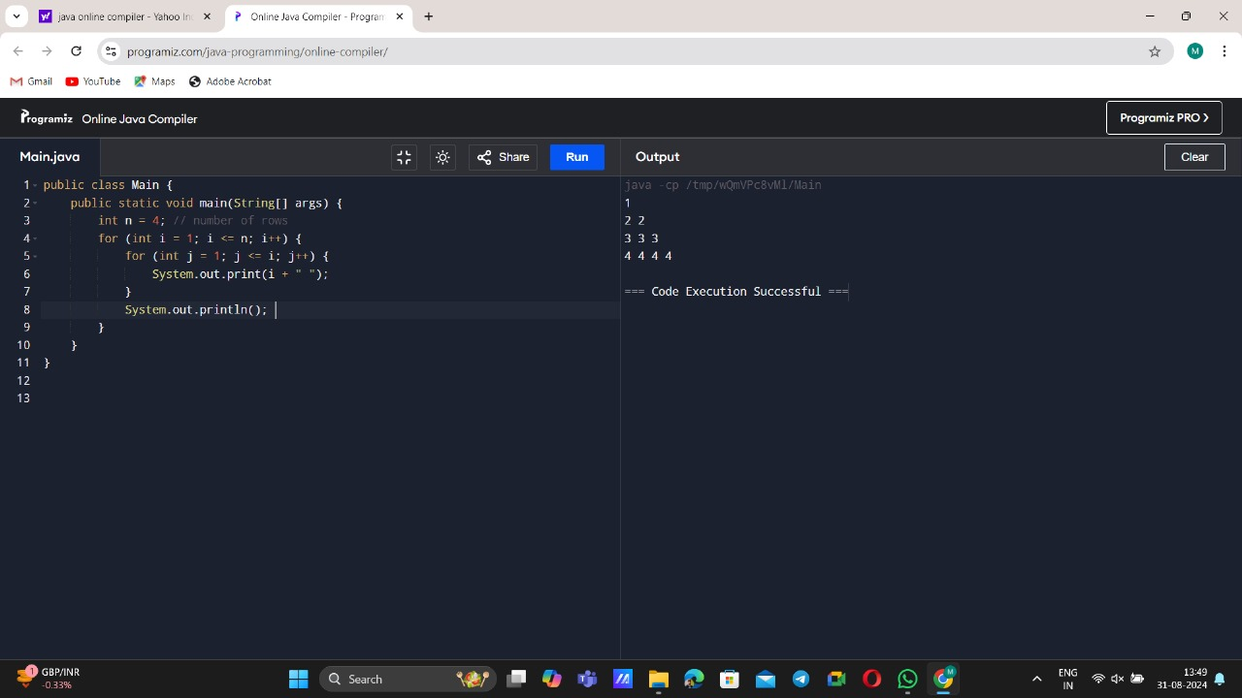

29) SQUARE AND CUBE OF A DECIMAL NUMBER

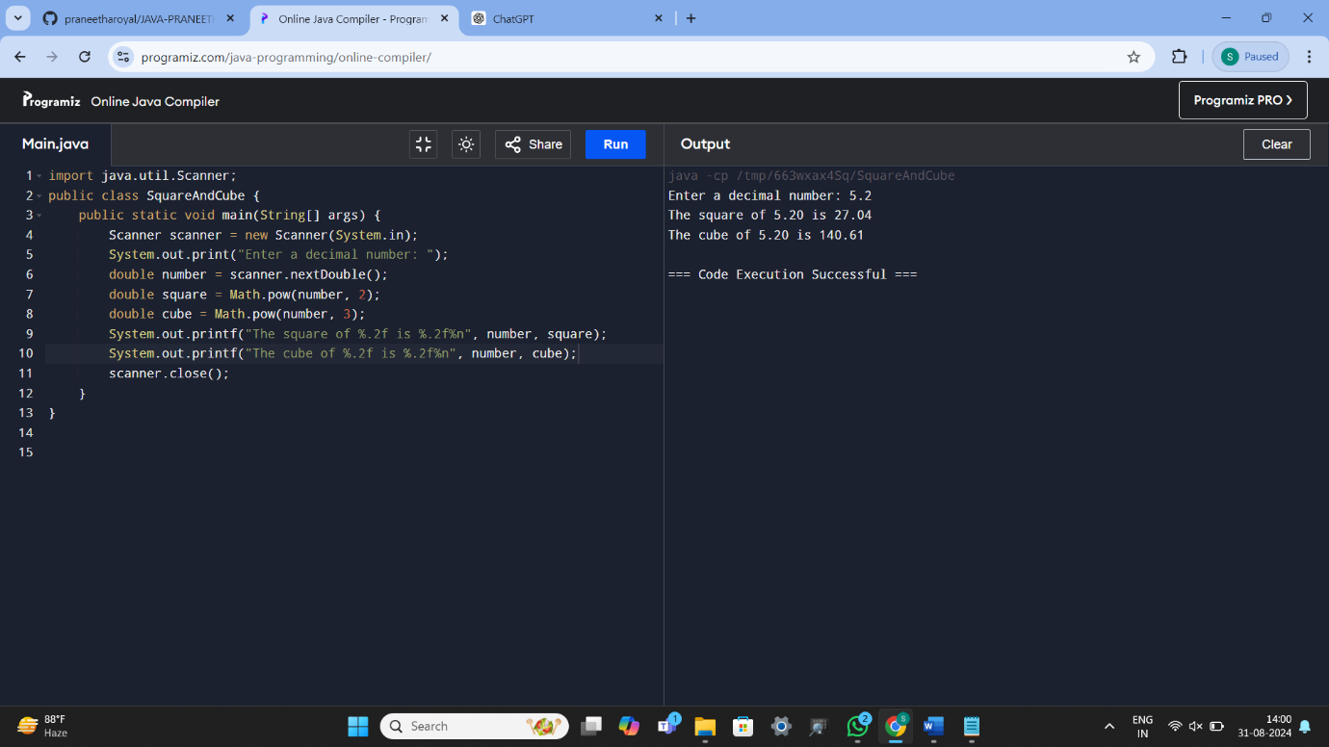

30) FREQUENCY OF THE GIVEN ARRAY

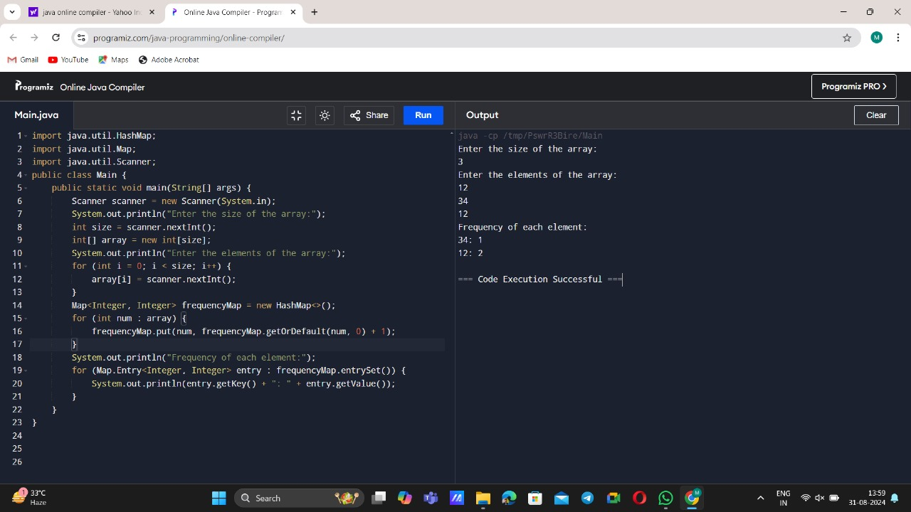

**DAY – 3**

31) PERFECT SQUARE PATTERN

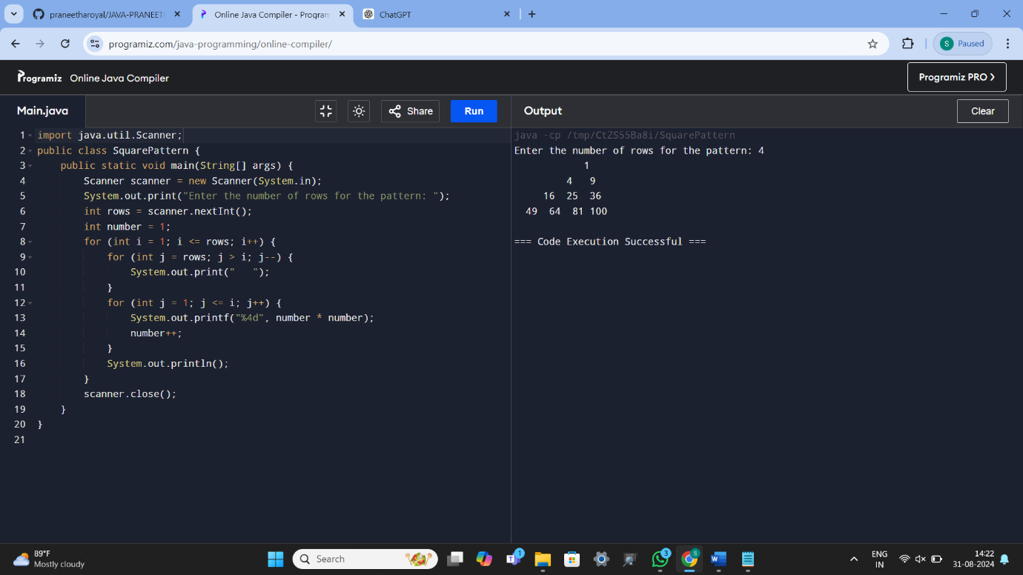

32) COMPOSITIE NUMBERS IN GIVEN ARRAY

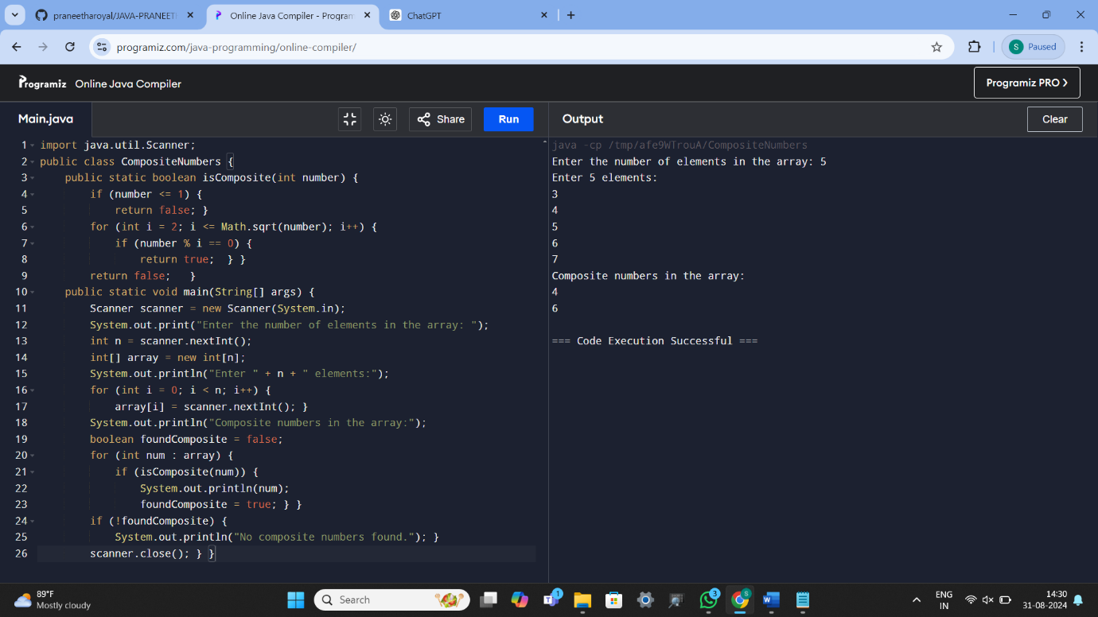

33) ARMSTRONG NUMBER

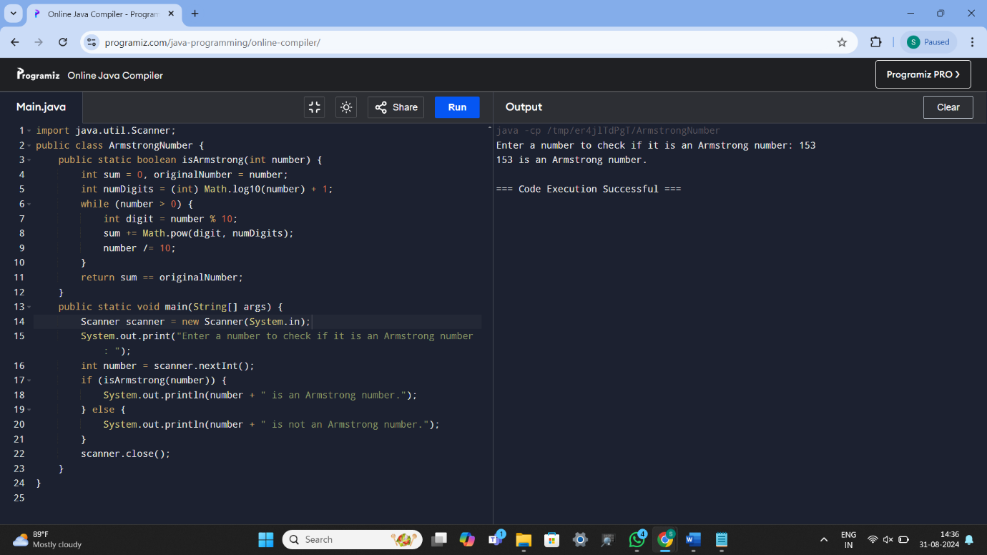

34) Nth ODD NUMBER AFTER N ODD NUMBER

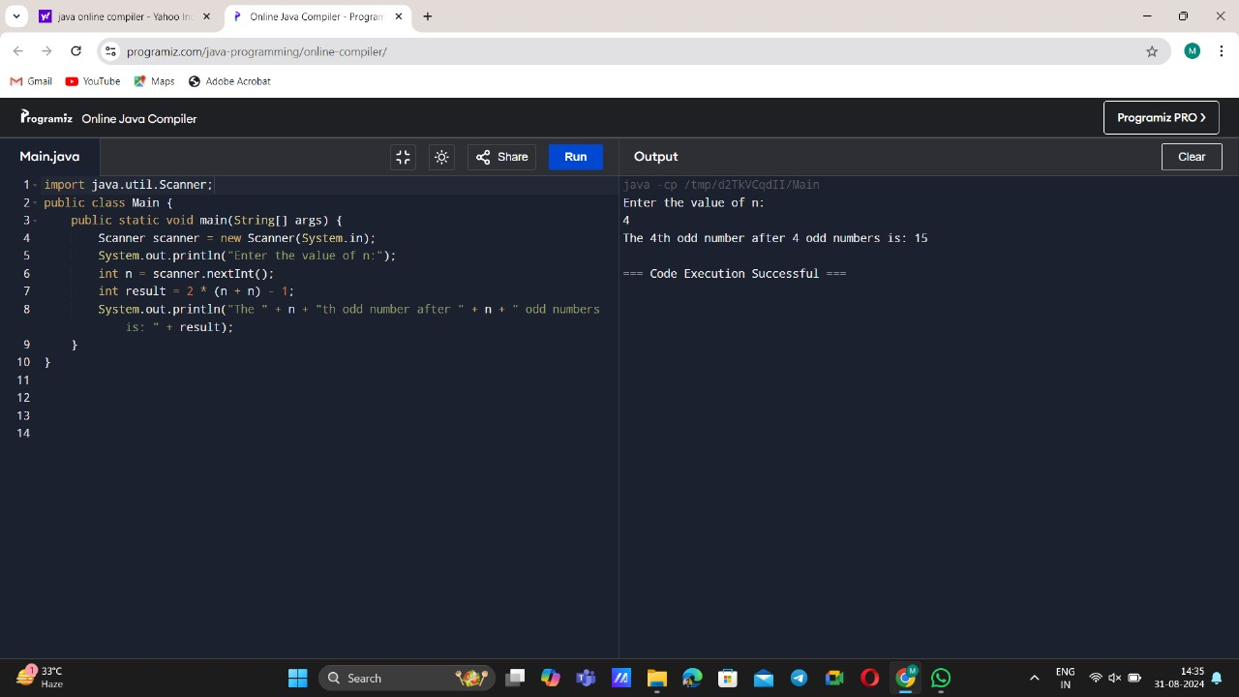

35) SQUARE ROOT OF PERFECT SQUARE NUMBER (+VE AND -VE)

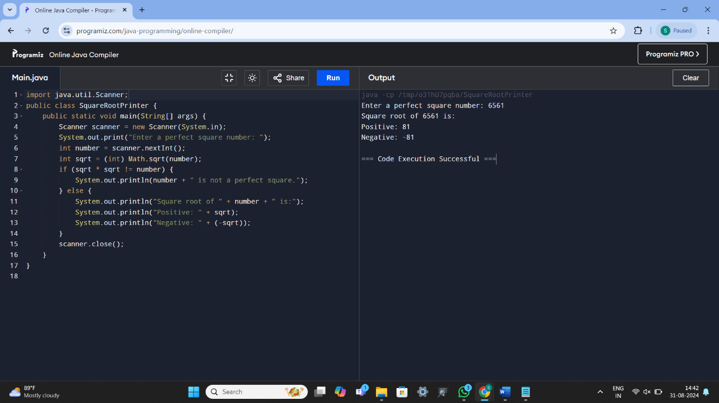

36) REMOVING VOWELS

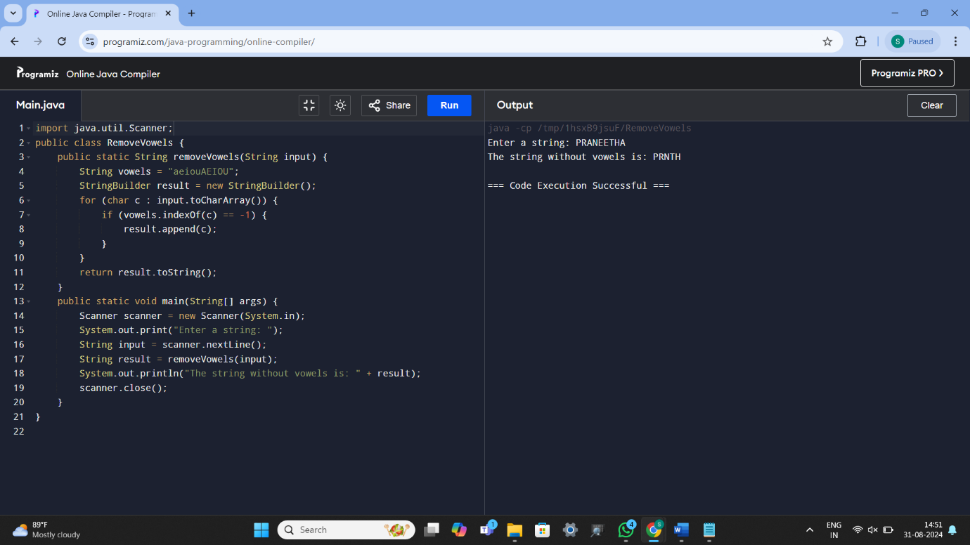

37) HOLLOW SQUARE DOLLAR PATTERN

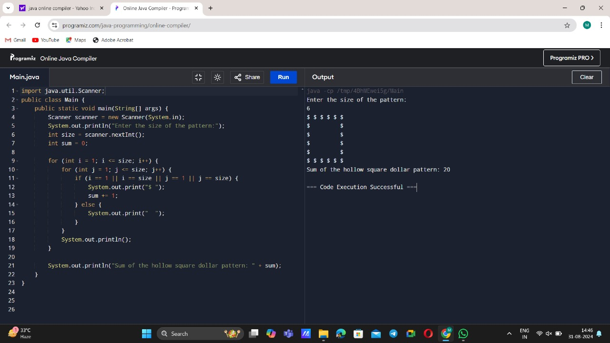

38) SUM OF DIGITS OF N DIGIT NUMBER

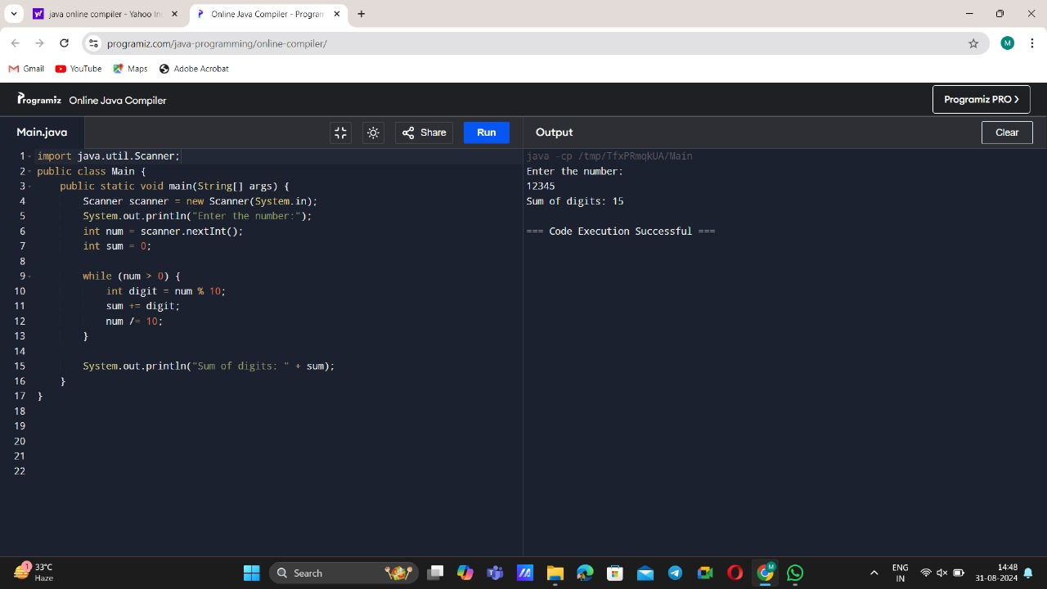

39) ARRANGE WORD ALPHABETICALLY IN REVERSE ORDER

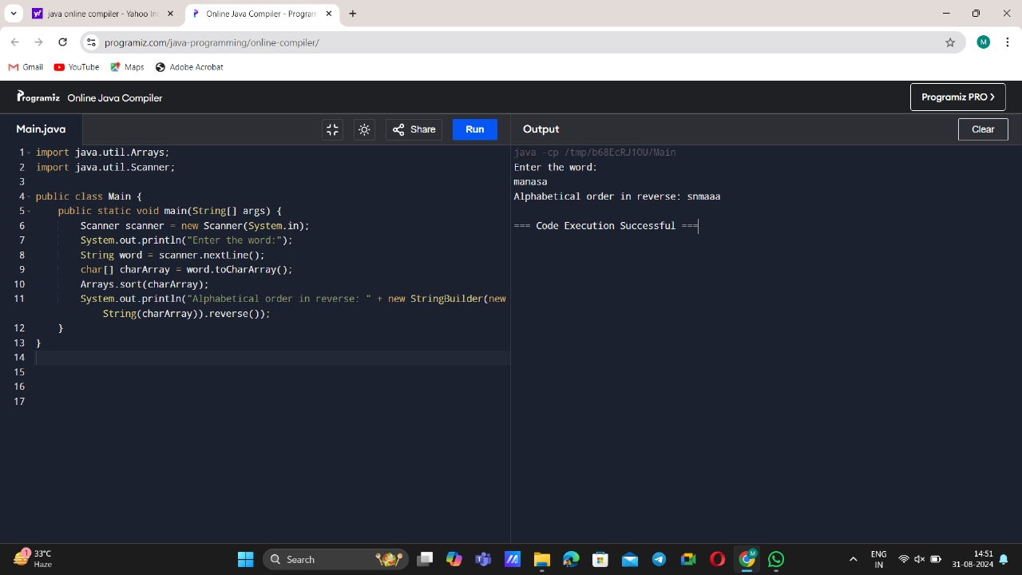

40) GIVEN CHARACTER IS PRESENT IN A STRING OR NOT

